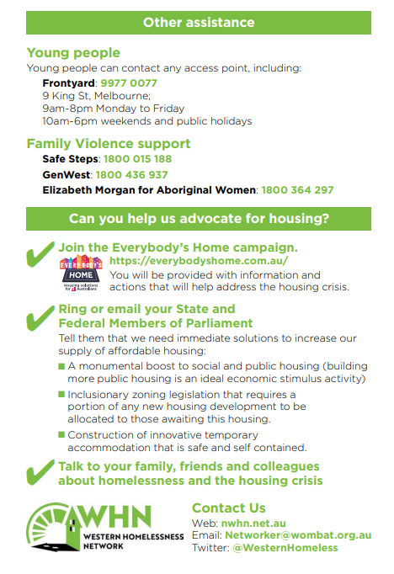

**Orange Doors**: [Contact Us | The Orange Door](https://www.orangedoor.vic.gov.au/contact)

**Elizabeth Morgan Aboriginal Women’s Service:** **1800 364 294**

Western Melb: 1800

34 Devonshire Rd, Sunshine

**9313 4700**

|  |  |  |  |
| --- | --- | --- | --- |
| **Unison** | **9689 2777**  **iap@unison.org.au** | **112 – 122 Victoria St Seddon** |  |
| **Unison outpost** | 9216 0300  iapwerribee@unison.org.au | Level 1, 1-3 Watton St Werribee |  |
| **Salvation Army Western Metro Homelessness Services** | 9313 4700  [sunshineIAP@salvationarmy.org.au](mailto:sunshineIAP@salvationarmy.org.au) | 6/147 Harvester Rd  Sunshine | Initial contact is generally by phone.  Service will be moving – July?    Melton outpost is currently closed. |

